Module 3 : Testing on Live Application :

Q1. What is RDMS.

* RDMS stands for Relational Database Management System in SQL.
* It's a type of database management system that stores data in a structured format, organized into tables with rows and columns.

Q2. What is SQL

* Its stands for Structured Query Language (SQL)
* SQL is the standard language used to interact with RDBMS. It allows users to perform various operations on the database, such as querying data, updating records, and defining database structures.

Q3. Write SQL Commands

* SQL commands are as follows:
* DDL – Data Definition Language
* DML – Data Manipulation Language
* DCL – Data Control Language
* DQL- Data Query Language

Q4. What is join?

* A join in SQL is a mechanism used to combine rows from two or more related tables based on a common column or relationship between them. The primary purpose of a join is to retrieve data from multiple tables in a relational database by linking rows that have matching values in specified columns.

Q5. Write type of joins.

* Joins are categorized into different types, such as INNER JOIN, LEFT JOIN, RIGHT JOIN, FULL JOIN.

Q6. How Many constraints and describes itself.

* Primary key : unique + not null
* Foreign key : its depends on primary table
* Unique key: only unique value
* Check : condition you should apply
* Not null : not to be blank
* Default: fixed value
* Index : when you search some records

Q7. Difference between RDBMS vs DBMS

|  |  |
| --- | --- |
| DBMS | RDBMS |
| * DBMS is a software system that enables users to define, create, maintain, and manage databases. * It provides basic functionalities for storing, retrieving, updating, and managing data without enforcing a specific data model. * In DBMS, data is stored in various formats, such as tables, files, or documents, and relationships between data are established manually. * Examples of DBMS include FileMaker, Microsoft Access, and SQLite.   databases. | * RDBMS is a specific type of DBMS that is based on the relational model of data. * It organizes data into tables (relations) consisting of rows and columns, where each table represents an entity, and relationships between entities are defined through keys. * RDBMS enforces the relational model's principles, including integrity constraints, such as primary keys, foreign keys, and referential integrity. * Examples of RDBMS include MySQL, PostgreSQL, Oracle Database, SQL Server, and SQLite (which can also function as both DBMS and RDBMS). |

Q8. What is API Testing

* API testing involves testing the Application Programming Interfaces (APIs) of software applications to ensure they function correctly, reliably, and securely. It focuses on testing the interaction between different software components or systems by sending requests to an API and verifying the responses.

Q9. Types of API Testing

* Open API’s
* Partner API’s
* Internal API’s

Q10. What is Responsive Testing?

* Responsive testing is the process of evaluating a website or web application to e+nsure that it adapts and displays correctly across various devices, screen sizes, and orientations.

Q11. Which types of tools are available for Responsive Testing.

* LT Browser
* Lembda Testing
* Google Resizer
* I am responsive
* Pixel tuner

Q12. What is the full form of .ipa, .apk

* Ipa stands for iOS App store Package
* Apk stands for Android Application Package

Q13. How to create step for to open the developer option mode ON?

1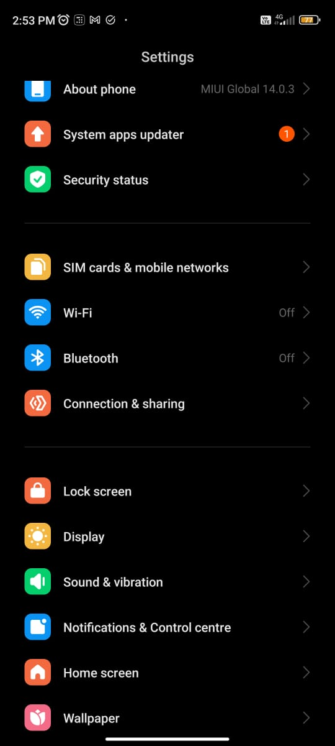 2 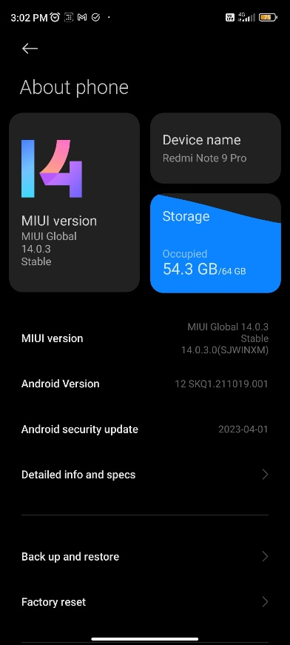 3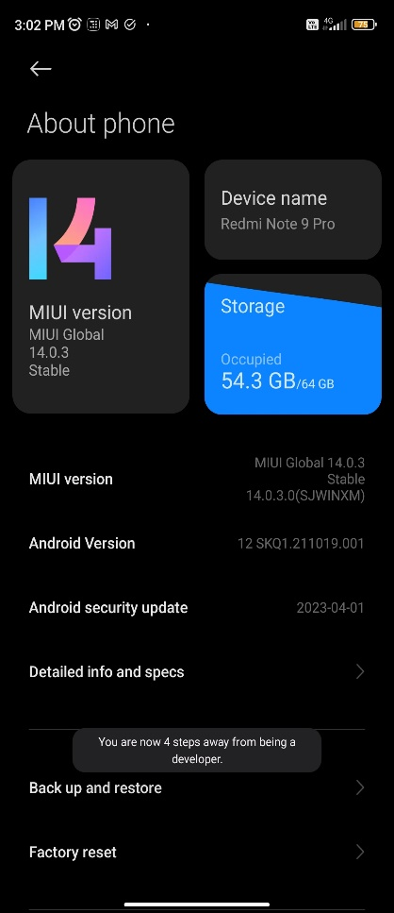 4 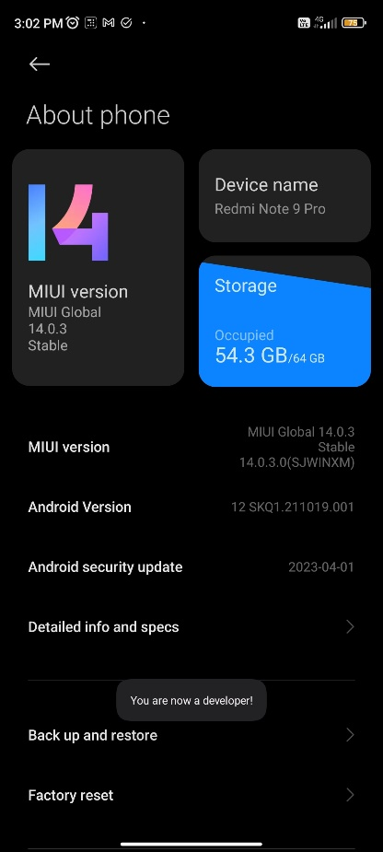

Q14. To Check

1 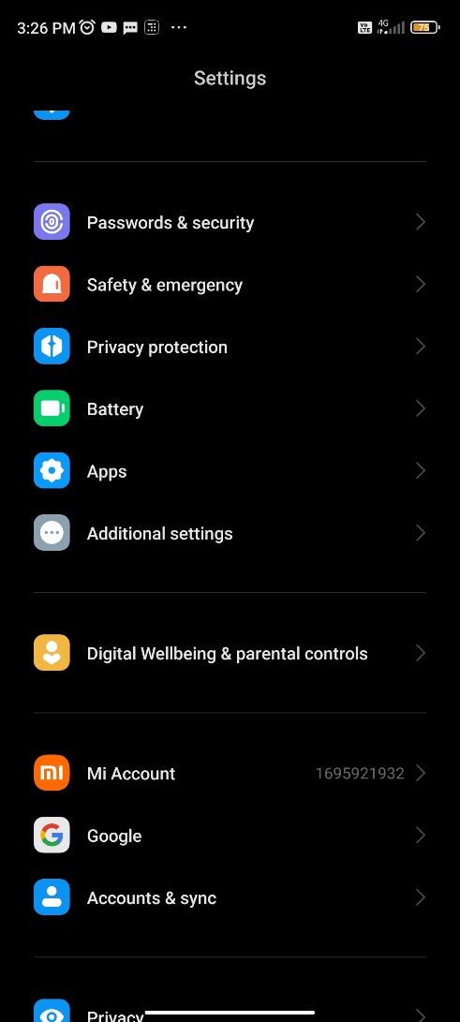 2) 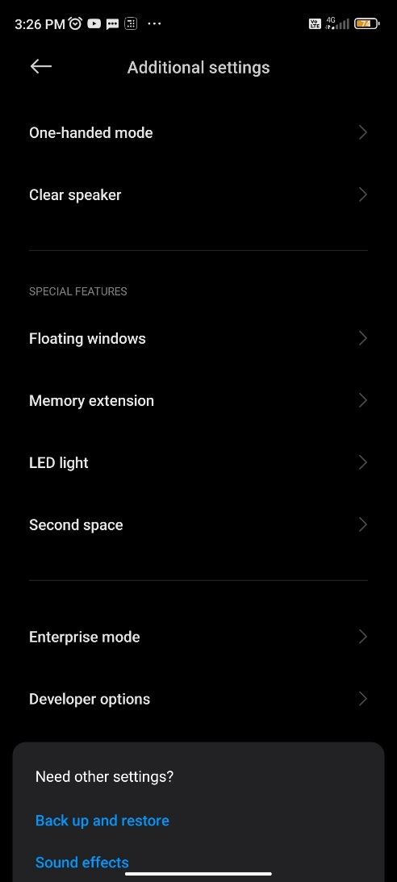 3) 